Good afternoon, Milena,
Welcome to your eighth and final English class. I hope you're having a beautiful day. Today we’ll explore one of the most powerful activities of the course, a challenge that blends storytelling, emotional intelligence, and professional fluency. The purpose is to help you develop a more natural, expressive, and emotionally grounded use of English, especially when narrating lived experiences from the perspectives of others.
As part of this session, we will read real fun facts about the Emberá Chamí culture and play an adapted version of Two Lies and One Truth, designed to deepen your awareness of Indigenous realities while practicing critical thinking and fluency.
Thank you for all the effort, openness, and creativity you’ve brought to each class. It’s been a pleasure accompanying you in this process. Let’s make this final session meaningful and full of voice.

🌿 Fun Facts – Emberá Chamí Culture & Language
- The Emberá Chamí language is still spoken by elders, women, and traditional healers, but younger generations are losing it fast due to lack of intercultural education.
- Language and health: Many Emberá women cannot describe symptoms in Spanish, which limits their access to adequate healthcare.
- Bilingualism as leadership: Women who speak both Emberá and Spanish often become informal translators and community advocates in health initiatives.
- Cultural expressions: Songs, prayers, and health knowledge are passed orally in Emberá, often through women and men.
- Community vision: Promoting the Emberá language is seen as a path to dignity, autonomy, and better inclusion in health and education programs.

- Umbrellas made from leaves: Emberá women often use large jungle leaves as umbrellas during the rainy season, they’re waterproof and biodegradable!
- Naming ceremonies: Emberá babies don’t always receive a name at birth. The community may wait to observe the baby’s traits or dreams before naming them.
- Bee stings as medicine: In some Emberá traditions, bee stings are used as a natural form of pain relief and to improve circulation.
- Hammock births: In rural Emberá communities, many women prefer to give birth in hammocks because they allow gravity to assist during labor.
- Colorful storytelling: Emberá oral stories are often told at night and include animal voices, singing, and gestures, it’s a full-body performance!
- Jagua ink tattoos: Emberá people traditionally paint their bodies with jaguar, a black ink from a fruit, for ceremonies, identity, or even mosquito protection.
- Plant-based toothbrushes: Some families use the stems of certain jungle plants to clean their teeth instead of store-bought toothbrushes.
- River timekeeping: Without watches or phones, some Emberá measure time by the position of the sun and the sound of the river, it tells them when to cook, bathe, or rest.
- Gendered clothing patterns: In traditional Emberá clothing, different geometric designs signal whether someone is single, married, or in mourning.
- Dream interpreters: Dreams are taken very seriously. Some elders are known in the community for helping others interpret dreams, especially those related to health or nature.
- No word for “goodbye”: In Emberá, there isn’t a direct word for “goodbye” people say “see you later” or speak in terms of returning.
- River salons: Women often gather by the river not just to bathe or wash clothes, but to talk, share news, and sing, it’s the social space of the day.
- Silence as respect: In Emberá culture, silence is often a sign of respect or deep listening, not discomfort.
- Forest classrooms: Many Emberá children learn the names of plants, trees, and animals before they learn to read, the forest is their first school.
- The moon and menstruation: Some Emberá women align their menstrual cycles with the moon and observe quiet days during that time as a way to restore balance and energy.

Two Lies and One Truth
- Emberá women never speak in public gatherings
Emberá communities are only found in Bogotá
There are more than 60 Emberá communities in Colombia and Panama
- Emberá traditional medicine is still used for childbirth
Emberá youth are not allowed to study beyond primary school
All Emberá elders have moved to cities for better healthcare
- Emberá midwives are respected and actively support women
The Emberá language has disappeared completely
Emberá women cannot own land or farm
- Most Emberá houses are built with palm leaves and wood
Emberá Chamí wear jeans and t-shirts for rituals
Only men are allowed to cook in Emberá communities
- Emberá women often sell beadwork to support their families
Emberá children are taught only in English
Emberá rituals are performed using smartphones
- Rivers are considered sacred by the Emberá Chamí
Only outsiders can become traditional healers
Drums are never used in Emberá ceremonies
- Emberá women are fully excluded from any political leadership
Emberá women help organize health programs in their territories
All Emberá schools are run by foreign missionaries
- The Emberá Chamí language has no word for “mountain”
Emberá girls participate in cultural learning from a young age
Emberá people don’t allow girls to attend school
- Emberá beadwork (chaquira) tells stories and carries meanings
Women are not allowed to make or wear necklaces
All Emberá crafts are imported from Ecuador
- Emberá communities celebrate with songs, food, and storytelling
Only men can dance in Emberá rituals
Women are not allowed to laugh in public
- Emberá traditional music uses flutes and drums
All Emberá songs are sung in Spanish
Music is considered a distraction from work
- Some Emberá women walk hours to attend health workshops
Women do not speak during any meetings
All Emberá women are expected to stay at home permanently
- Emberá Chamí believe the forest is a living, spiritual being
Women cannot go near trees after sunset
The community forbids planting medicinal herbs
- Emberá women lead training sessions on nutrition and childcare
Only men are allowed to speak to health professionals
Women are forbidden from using health centers
- Some Emberá communities use storytelling as a teaching method
Elders are not consulted for any decision
Children are discouraged from asking questions
Correct Answers:
- There are more than 60 Emberá communities in Colombia and Panama
- Emberá traditional medicine is still used for childbirth
- Emberá midwives are respected and actively support women
- Most Emberá houses are built with palm leaves and wood
- Emberá women often sell beadwork to support their families
- Rivers are considered sacred by the Emberá Chamí
- Emberá women help organize health programs in their territories
- Emberá girls participate in cultural learning from a young age
- Emberá beadwork (chaquira) tells stories and carries meanings
- Emberá communities celebrate with songs, food, and storytelling
- Emberá traditional music uses flutes and drums
- Some Emberá women walk hours to attend health workshops
- Emberá Chamí believe the forest is a living, spiritual being
- Emberá women lead training sessions on nutrition and childcare
- Some Emberá communities use storytelling as a teaching method

Eight class Milena.mp3
Dear Milena,
I want to take a moment to thank you deeply, not only for your dedication and commitment to your English learning process, but also for the immense value you’ve brought to our classes. You have been fully present, intentional, and engaged with your purpose, and it truly shows.
Thanks to our conversations, I’ve had the privilege of learning so much about Indigenous cultures, especially the Emberá communities, and about critical public health topics like yellow fever, its risks, and its impact on vulnerable populations. Your stories, your insights, and the way you speak from lived experience have inspired me to reconnect with knowledge I hadn’t explored in a long time. You've helped me see things through a more informed and human lens, and I’m truly grateful for that.
It is an honor to have you as one of my students. You are a brilliant, knowledgeable woman with so much to offer the world, and I’m excited to continue walking alongside you in your learning journey.
I have many ideas in mind to continue supporting your academic growth. You are always welcome to continue with this process, the door is wide open. I’ll soon share the updated academic proposal with you, including several class package options so you can choose the one that best fits your needs and goals.
The purpose moving forward would be to strengthen your fluency even more, making your English more conversational, expressive, and aligned with your professional purpose.
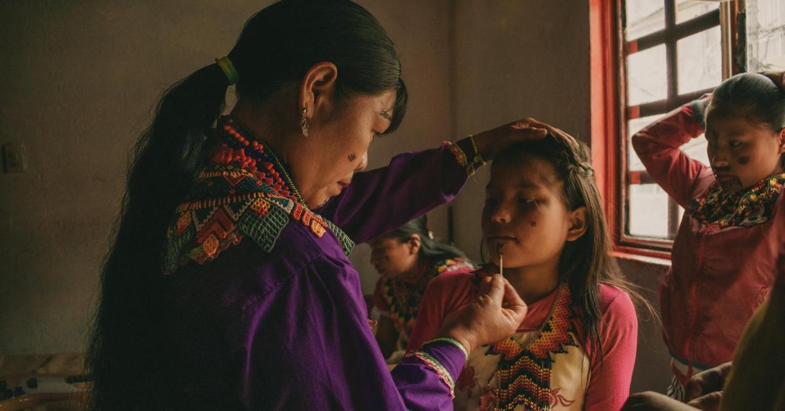
Thank you again for the opportunity to learn with you. I look forward to everything we can continue building together.
Warmly,
Teacher Andrea

CONTINUING YOUR ACADEMIC JOURNEY IN ENGLISH
As we look forward to continuing your academic journey in English, I want to share one of the ideas I have in mind for your upcoming classes.
One focus will be to explore the institution where you currently work: CIDEIM, the International Center for Training and Medical Research.
We will take time to study its mission, vision, and long-standing commitment to improving health through research, particularly in infectious diseases that affect vulnerable populations in Colombia and Latin America.
Understanding the institutional context where your research takes place will allow us to practice technical vocabulary and express complex ideas with fluency and confidence.
We will also discuss what it means to hold a postdoctoral position in Social Sciences.
This will include reflection on the role of researchers in public health innovation, the challenges of working on poverty-associated diseases, and how social innovation can be applied in the field.
We will go deeper into the kind of work you develop in the SIHI LAC Hub and how this initiative strengthens training and knowledge-sharing across Latin America and the Caribbean.
These conversations will help you expand your speaking abilities around interdisciplinary research and leadership.
Another theme will be your academic formation.
We will explore how it feels to study abroad, especially your experience at the University of Granada in Spain, both during your master’s program in Social Problems and your PhD in Social Sciences.
We will talk about the value of your education and how it shaped your professional path.
This will give us a rich opportunity to practice narratives of academic and professional development, especially in international settings.
I also plan for us to reflect on the mission and global partnerships that support CIDEIM’s work, including programs such as TDR, the Special Programme for Research and Training in Tropical Diseases, and the Swedish International Development Cooperation Agency (Sida).
Learning about these institutions will strengthen your ability to describe and contextualize your work to an international audience.
Additionally, we will dedicate time to the audiovisual material you shared, which provides valuable cultural and scientific insights related to your work.
This will allow us to build vocabulary, improve pronunciation, and connect ideas through storytelling and analysis.
All of these topics are meaningful not only for your professional communication in English, but also for deepening your ability to speak with clarity, pride, and impact about the important work you do.
It will be a pleasure to accompany you in this next phase, and I’m truly excited for everything we will continue to learn together.

Paquete de Clases de Speaking – Conversación Guiada

